**INF3014F Individual project**

**Name: Mnelisi Mabuza**

**Student number: MBZMNE001**

**Date: 21/04/2024**

**Business Canvas:**

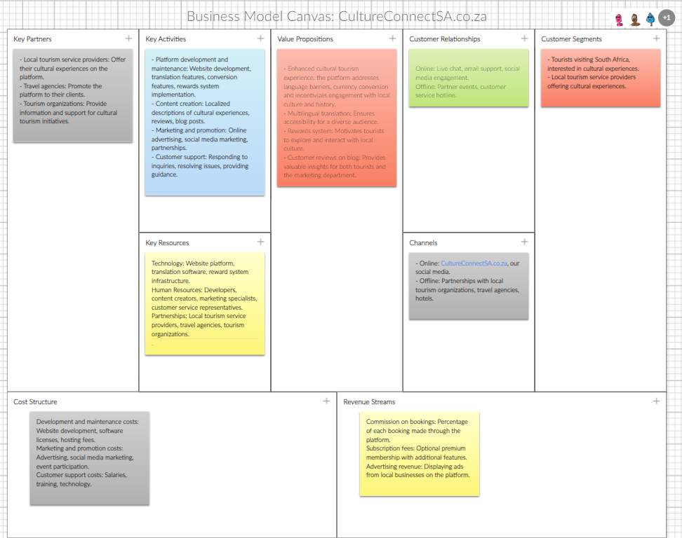

**Introduction:**

This report outlines the user experience (UX) design for a tourism eCommerce platform designed to enhance the cultural tourism experience in South Africa. The report includes the development of user personas, user journey map, and wireframes and finally a prototype to ensure a seamless and intuitive user experience.

**User Personas:**

**Persona 1: Cultural & History Enthusiast**

Name: Sarah Jones



*"I'm looking for a platform that offers a variety of authentic and immersive cultural experiences which will provide me with almost everything I need to get set to be Dora the Culture Explorer!"*

About: Sarah Jones is a 28-year-old marketing professional from the United States. She is single and enjoys traveling solo to explore new cultures and learn about history. She is a college graduate with a degree in marketing and works full-time at a marketing agency. She typically works 40 hours per week in an office environment.

Key Motivations and Needs:

* To learn about the history and culture of South Africa.
* To experience authentic cultural activities.
* To connect with local people.
* To have a unique and memorable travel experience.
* To use technology to enhance her travel experience.

Thoughts, Feelings, and Opinions:

Sarah is excited about the prospect of visiting South Africa and learning about its rich history and culture.

She is looking for a platform that offers a variety of authentic and immersive cultural experiences.

She is comfortable using technology and appreciates platforms that are easy to use and navigate.

She is particularly interested in the multilingual feature of the platform, as she is not fluent in English and using translation apps can be a lot of work.

How Sarah Currently Solves Her Problems:

Sarah typically researches travel destinations online and uses travel blogs and social media to find recommendations for cultural experiences.

She often books tours and activities through online travel agencies.

She uses language translation apps.

Frustrations with the Current Solution:

Sarah finds it challenging to find information about authentic cultural experiences in South Africa. She is often frustrated by the lack of multilingual support on travel websites and apps. She wishes there was a single platform where she could find and book all of her cultural experiences.

Preferred Devices:

* Smartphone
* Laptop

How the Product Meets Sarah's Needs:

* The platform provides Sarah with a wide range of cultural experiences to choose from, including those that are specifically designed for solo travelers.
* The multilingual feature and currency converter allows Sarah to easily navigate the platform and understand the information provided.
* The Culture Quest challenge incentivizes Sarah to explore different parts of South Africa and engage with the local culture.
* The blog page provides Sarah with valuable information about previous events and what other tourists have experienced.

**Persona 2: Family Traveler**

Name: John Smith



*"I want to make sure that my family has a fun and educational vacation."*

About: John Smith is a 42-year-old French accountant who is married with two young children (ages 8 and 10). He lives in a suburb of Paris and works full-time at an accounting firm. He typically works 40 hours per week in an office environment.

Key Motivations and Needs:

* To have a fun and educational family vacation
* To learn about the history and culture of South Africa
* To find activities that are suitable for all ages
* To create lasting memories with his family
* To use technology to plan and book their trip

Thoughts, Feelings, and Opinions:

John is excited about the prospect of taking his family to South Africa and experiencing its diverse culture.

He is looking for a platform that offers a variety of family-friendly activities and attractions.

He is concerned about the language barrier and wants to make sure that his family can easily communicate with locals.

How John Currently Solves His Problems:

John typically researches travel destinations online and uses travel blogs and social media to find recommendations for family-friendly activities.

He often books tours and activities through online travel agencies.

He uses language translation apps to communicate with locals when necessary.

Frustrations with the Current Solution:

John finds it challenging to find information about family-friendly cultural experiences in South Africa.

He is often frustrated by the lack of multilingual & currency conversion support on travel websites and apps.

He wishes there was a single platform where he could find and book all of his family's cultural experiences.

Preferred Devices:

* Smartphone
* Laptop

How the Product Meets John's Needs:

The platform provides John with a wide range of family-friendly cultural experiences to choose from.

The multilingual feature and currency converter allows John and his family to easily navigate the platform and understand the information provided which makes it easier for them to engage with the platform.

The Culture Quest challenge incentivizes John and his family to explore different parts of South Africa and engage with the local culture.

The blog page provides John with valuable information about previous events and what other tourists have experienced.

USER CONTEXT:

**What is the product for?**

* The product is a tourism eCommerce platform designed to enhance the cultural & history tourism experience in South Africa. The platform aims to connect tourists with the rich history, vibrant traditions, and diverse communities that make this country so special.

**Who is going to use the product?**

* The primary target audiences are tourists visiting South Africa who are interested in cultural & historical experiences while enjoying a luxury stay. The secondary target audience is local tourism service providers offering cultural & historical experiences.

**Where is the product going to be used?**

* The product can be used on any device with an internet connection, such as a computer, smartphone, or tablet.

**How will the product be used to support the users’ work?**

For the primary target audience (tourists):

* Find and book cultural experiences.
* Learn about South African history and culture.
* Read reviews of cultural experiences.
* Connect with local tourism service providers.
* Share their experiences with others.

For the secondary target audience (local tourism service providers):

* List their cultural experiences on the platform.
* Manage bookings.
* Communicate with tourists.
* Promote their services to a wider audience.

Hierarchical task analysis:

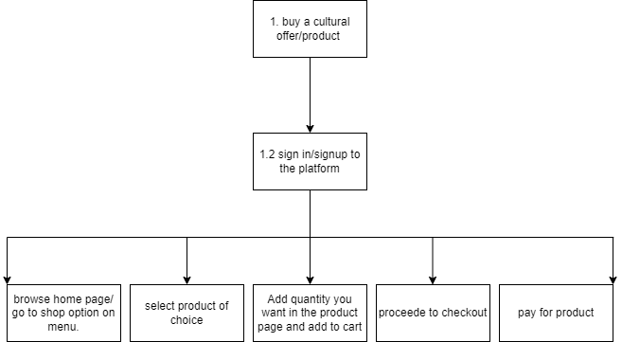

**Design Goals and Design Style**

Design Goals:

* + User-friendly.
  + Informative.
  + visually appealing and engaging.
  + Accessible.
  + Mobile-friendly.

Design Style:

* Modern.
* Colorful.
* Culturally sensitive: respectful of South African culture and traditions.
* Interactive.
* Personalized.

**Wireframes:**

*Home page:*

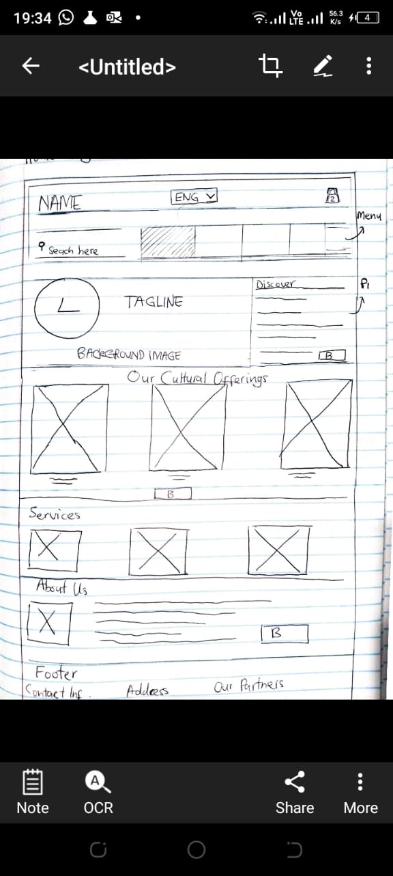

*Product page 1.1:*

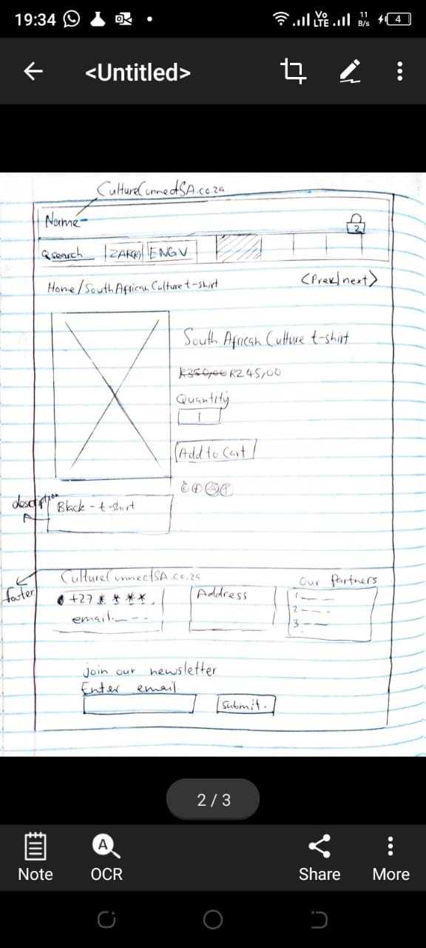

*Product page 1.2:*

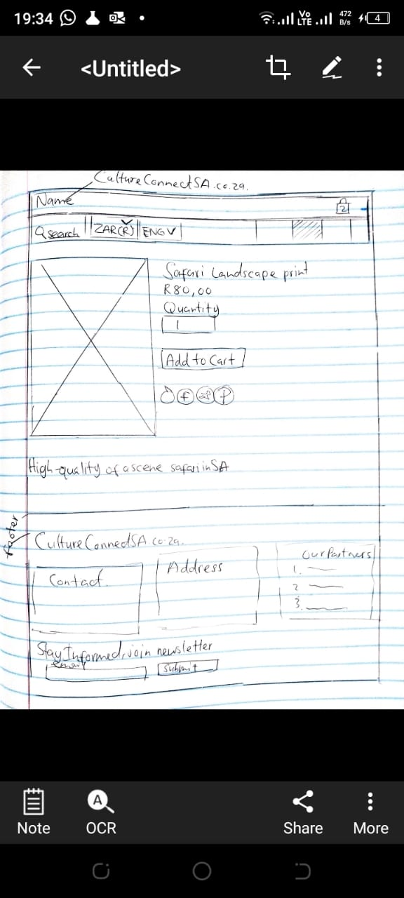

**Prototype:**

*Wix link:*[**https://wiseymabuza.wixsite.com/cultureconnectsa**](https://wiseymabuza.wixsite.com/cultureconnectsa)